## Exp. 1Design an LED FLASHER

Circuit Diagram:

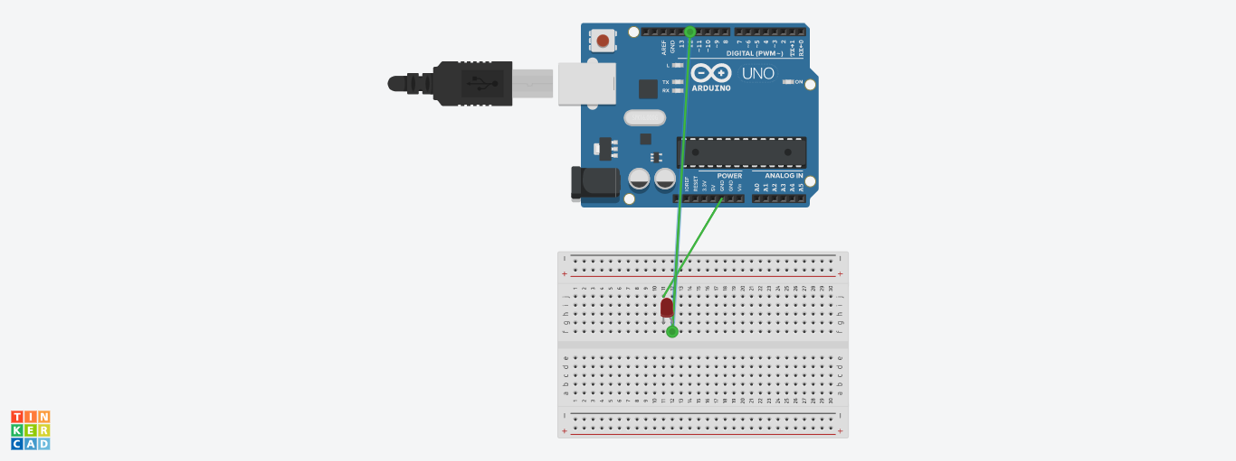

Theory

Concept Used : In led FLASHER, The led glow and dim after few second.

Learning & Observations:

The led light glow one as shown like flash .

Problems & Troubleshooting:

1. Problem in fixing wire from bread board to arduino.
2. Problem in doing arduino programming.

Precautions:

1. Correct conection of negative and positive terminal of led.
2. Don’t put arduino near water.
3. Check the USB port of computer is working .
4. Check the arduino software and select the correct port (in which arduino is connected).

Learning Outcome:

1. LED light glow in the sequence of 12,8,5.
2. Arduino function as a controller in led chaser.
3. Bread board is used to organize the circuit.